**WEB TECHNOLOGY**

**-19BIT050**

**-19BIT201**

**1) DTD Validation :**

**CUSTOMER.XML**

<?xml version="1.0" encoding="UTF-8"?>

<!DOCTYPE customer SYSTEM "./customer.dtd">

<customer>

<name>Natarajan</name>

<firstname>Selvam</firstname>

<address>

<streetname>3rd cross street</streetname>

<place>Ranganpalayam</place>

<city>Erode</city>

<phonenno>9876543210</phoneno>

</address>

<purchaseInfo>

<orderNo>001</orderNo>

<itemList>

<itemNo>12</itemNo>

<itemName>Mango</itemName>

<quantity>2</quantity>

</itemList>

<amount>100</amount>

</purchaseInfo>

<cusType>regular</cusType>

</customer>

**CUSTOMER.DTD**

<!ELEMENT customer (name,address,purchaseInfo,cusType)>

<!ELEMENT name (firstname, lastname)>

<!ELEMENT firstname (#PCDATA)>

<!ELEMENT lastname (#PCDATA)>

<!ELEMENT address (streetname, place, city, phoneno)>

<!ELEMENT streetname (#PCDATA)>

<!ELEMENT place (#PCDATA)>

<!ELEMENT city (#PCDATA)>

<!ELEMENT phoneno (#PCDATA)>

<!ELEMENT purchaseInfo (orderNo,itemList,amount)>

<!ELEMENT orderNo (#PCDATA)>

<!ELEMENT itemList (itemNo,itemName,quantity)>

<!ELEMENT itemNo (#PCDATA)>

<!ELEMENT itemName (#PCDATA)>

<!ELEMENT quantity (#PCDATA)>

<!ELEMENT amount (#PCDATA)>

<!ELEMENT cusType (#PCDATA)>

**OUTPUT :**

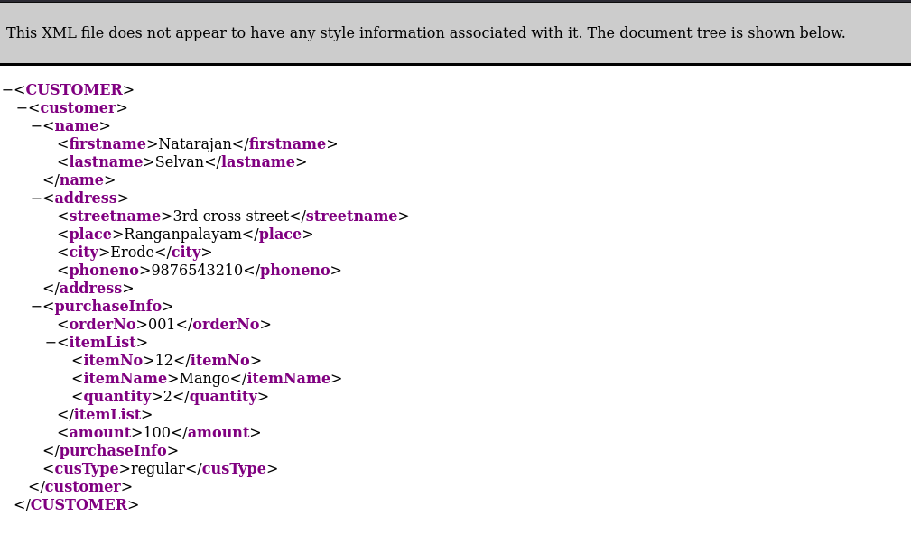

**index.html:**

<!DOCTYPE html>

<html lang="en">

<head>

<meta charset="UTF-8" />

<meta http-equiv="X-UA-Compatible" content="IE=edge" />

<meta name="viewport" content="width=device-width, initial-scale=1.0" />

<link rel="stylesheet" href="./style.css" />

<title>Character Count</title>

</head>

<body>

<main>

<label for="inp-string">Text</label>

<input type="text" id="inp-string" />

<label for="char-count">No of characters</label>

<input type="text" id="count-disp" readonly/>

<button id="count">Count</button>

</main>

<script src="./main.js"></script>

</body>

</html>

**Main.js**

const inpStringTag = document.querySelector("#inp-string");

const countDisp = document.querySelector("#count-disp");

const countBtn = document.querySelector("#count");

countBtn.addEventListener("click", countChars)

function countChars(){

const string = inpStringTag.value;

const whiteSpaces = string.split(" ").length-1;

countDisp.value=string.length - whiteSpaces;

}

**Style.css:**

*,

*::before,

*::after {

margin: 0;

padding: 0;

box-sizing: border-box;

}

button,input{

font:inherit;

}

body {

width: 100%;

min-height: 100vh;

display: flex;

justify-content: center;

align-items: center;

font-size:1.5rem;

}

main{

display: flex;

flex-direction: column;

border: 2px solid #aaa;

padding: 2rem 3.5rem;

}

main > label{

padding:.8rem 0;

}

main > input{

padding:.5rem;

margin: .5rem 0;

}

button{

margin: 1.5rem 0;

padding:.5rem 0;

cursor: pointer;

}

**Screen shots:**

